Android Developer Bootcamp
Text and Image Display Screen
Workshop #02

🎯 Purpose
This workshop helps you practice displaying text and images using XML layout only.
You will use basic UI components to create a simple screen containing a TextView and an ImageView.
🧩 Problem
Design a simple screen UI in Android using XML.
The screen should contain the following elements:
🏷️ Welcome Text
• A TextView at the top
• Text should be: "Welcome to Android"
• It should be centered and clearly visible
🖼️ Image Display
• An ImageView below the TextView
• Display any image from the drawable folder
• The image should be clearly visible
• Keep the image centered on the screen
How to Solve
Checkout the workshop from Git Repo:
1 . git clone -b
- Open the root folder inside Android Studio
- Open activity_main.xml
- Add an ImageView
- Run the application
🎯 You Will Achieve
After completing this workshop, you will understand:
• How to use TextView in Android XML
• How to display images using ImageView
• How to set image resources from the drawable folder
📸 Screenshots
Before Implementation

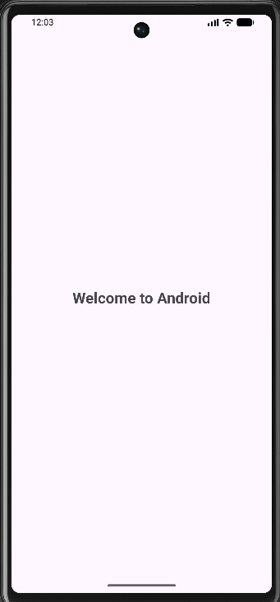

After Implementation
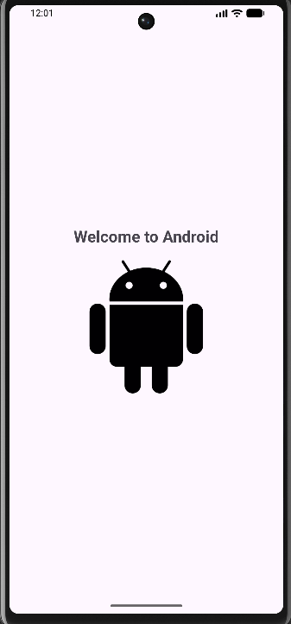

How to submit your workshop
Push your project back to the same git branch using command:
git add .
git commit -m "Completed TextView and ImageView Workshop"
git push origin <user-branch>
🚀 Happy Coding!

